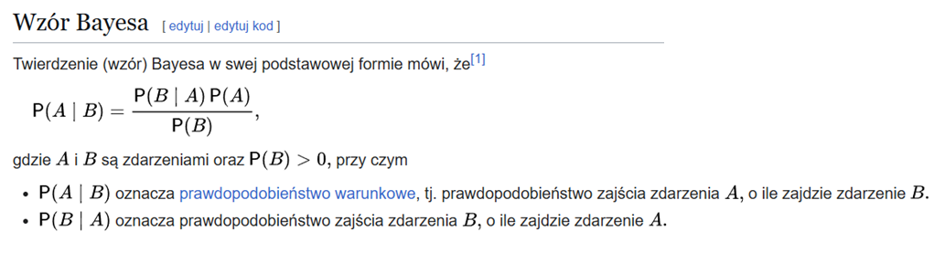

# Zadanie 4

### Podpunkt 1

### Podpunkt 2

# Zadanie 5

### Podpunkt 1 – wyznaczyć rozkład

|  |  |  |
| --- | --- | --- |
|  |  |  |
|  | 0,02 | 0,08 |
|  | 0,18 | 0,72 |

### Podpunkt 2 – wyznaczyć rozkład

|  |  |
| --- | --- |
|  |  |
| 0,2 | 0,8 |

### Podpunkt 3 – sprawdzić, czy A i C są warunkowo niezależne pod warunkiem B

|  |  |  |  |  |  |
| --- | --- | --- | --- | --- | --- |
|  |  | 0,3 | 0,7 | 0,6 | 0,4 |
|  | X * Y |  |  |  |  |
| 0,1 |  | 0,03 | 0,07 | 0,06 | 0,04 |
| 0,9 |  | 0,27 | 0,63 | 0,54 | 0,36 |
| 0,1 |  | 0,03 | 0,07 | 0,06 | 0,04 |
| 0,9 |  | 0,27 | 0,63 | 0,54 | 0,36 |

# Zadanie 6

### Podpunkt 1

### Podpunt 2

### Podpunkt 3

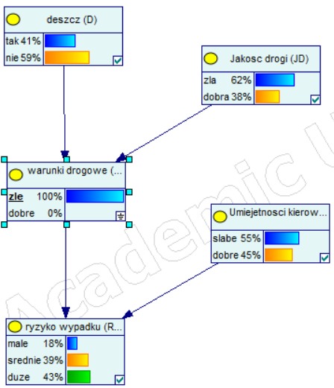

### Podpunkt 4

# Zadanie 4 wykonane w programiie GeNIe

### Utworzona sieć

### Podpunkt 1

### Podpunkt 2

# Zadanie z teamsów

### Utworzona sieć

### Prawdopodobieństwo danego przypadku - przykład

### Obliczanie przypadków

|  |  |  |  |  |
| --- | --- | --- | --- | --- |
| L.p. | a | b | c |  |
| 1 | 0 | 0 | 0 | 0,012 |
| 2 | 0 | 0 | 1 | 0,108 |
| 3 | 1 | 0 | 0 | 0,144 |
| 4 | 1 | 0 | 1 | 0,336 |
| 5 | 0 | 1 | 0 | 0,032 |
| 6 | 0 | 1 | 1 | 0,048 |
| 7 | 1 | 1 | 0 | 0,032 |
| 8 | 1 | 1 | 1 | 0,288 |

|  |  |  |
| --- | --- | --- |
| C \ B | State0 | State1 |
| State0 | 0,156 | 0,064 |
| State1 | 0,444 | 0,336 |

# Zadanie z teamsów

Zweryfikować niezależność zmiennych B i C pod względem zmiennej A

### Utworzona sieć

Obliczenia

